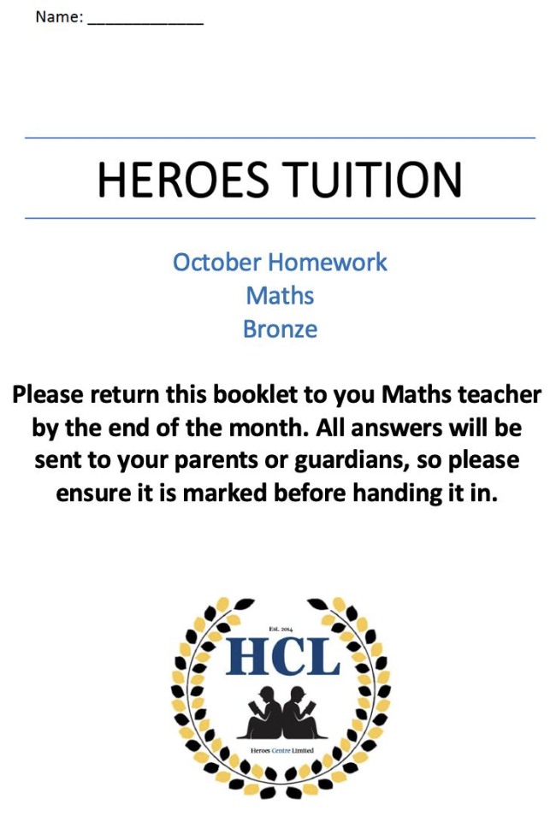
Silver

Heroes Tuition Centre - Homework
© Corbettmaths 2017 www.corbettmaths.com
Name: Silver
Primary 5-a-day

1st October
100 × 100 | 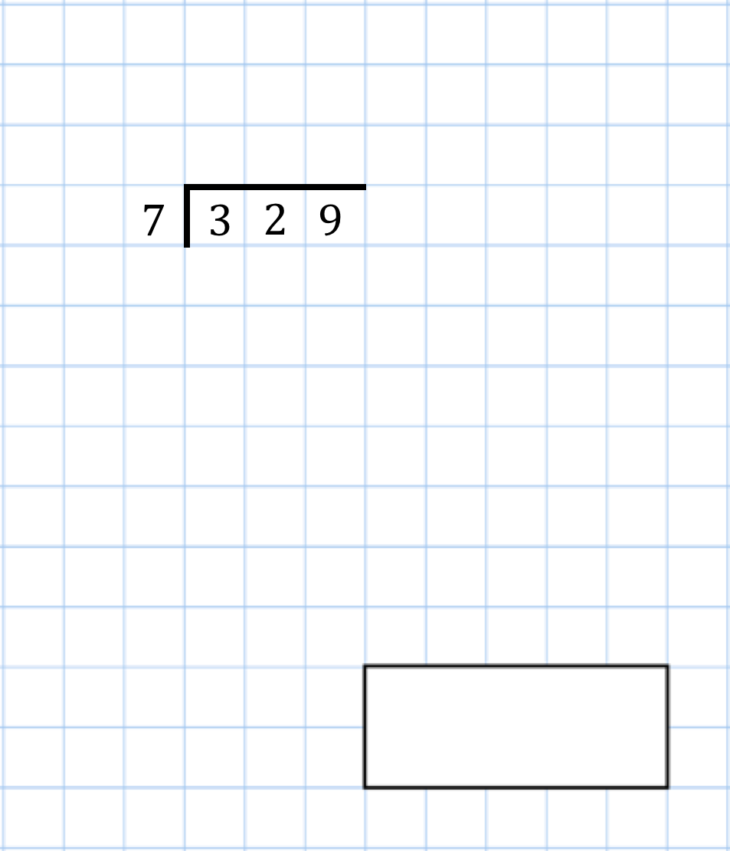
Tick each shape that has more vertices than faces | 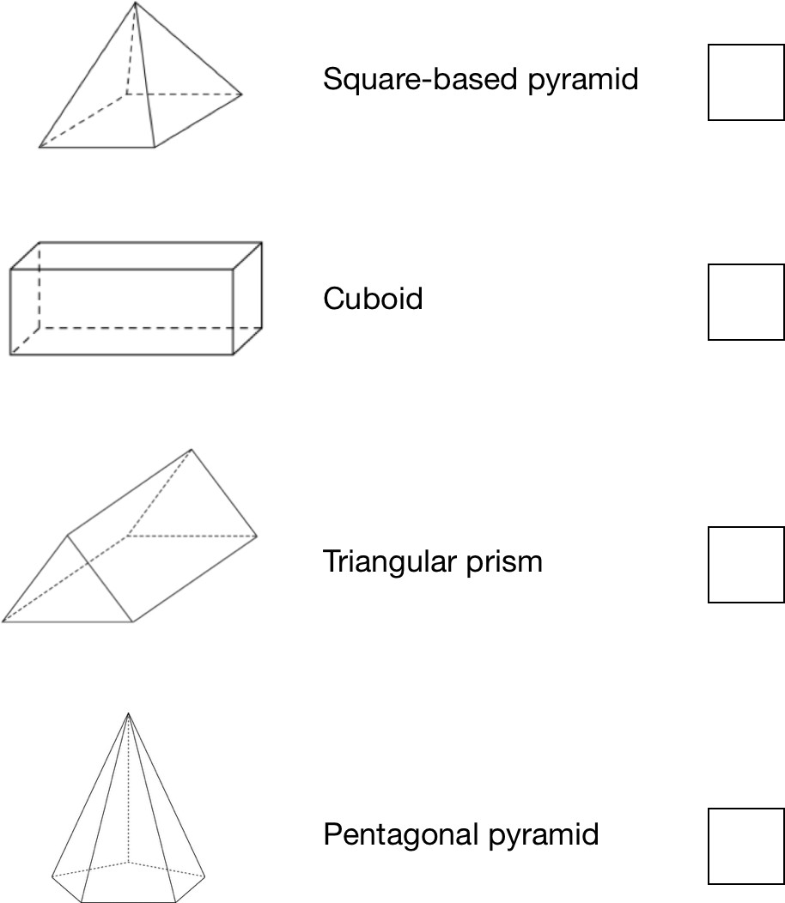
There are green, pink and blue beads in a bag. There are 40 beads altogether.  1  5 of the beads are green  3  4 of the beads are pink | How many blue beads are there in the bag?

Heroes Tuition Centre - Homework
© Corbettmaths 2017 www.corbettmaths.com

Name: Silver
Primary 5-a-day

2nd October
540 ÷ 6 | 8,000 − 80
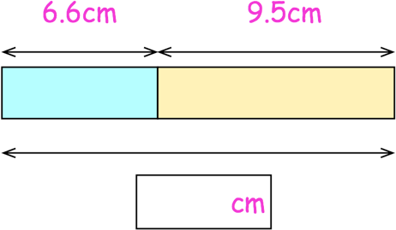 | Work out the total length of the two blocks.
Sam has a bag of 10p coins. Tyler has a bag of 50p coins.

Both bags have the same amount of money inside.

There are forty 10p coins in Sam’s bag.

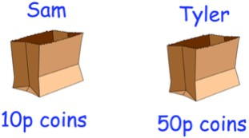

How many coins do they have altogether?

Heroes Tuition Centre - Homework
© Corbettmaths 2017 www.corbettmaths.com

Name: Silver
Primary 5-a-day

3rd October
2 + 2  5 5 | 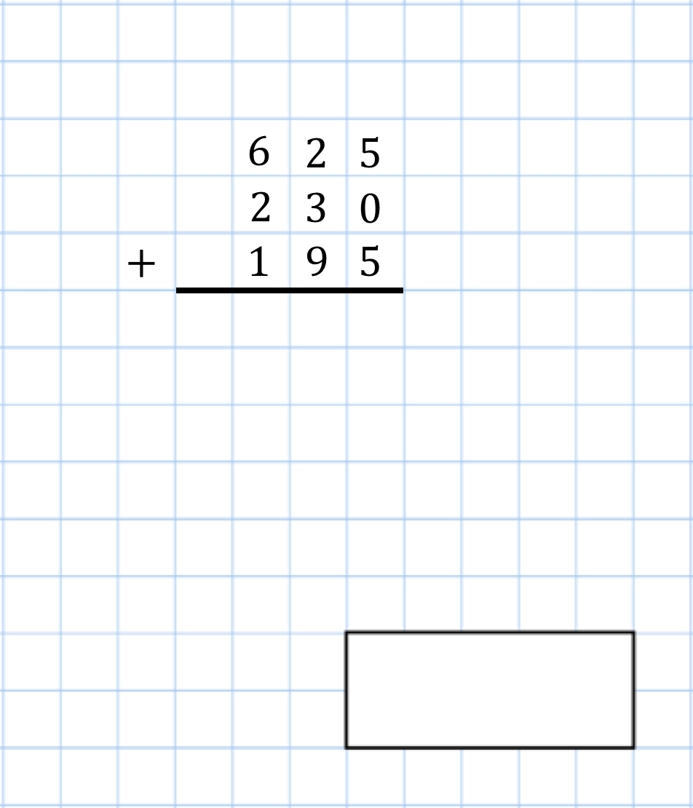
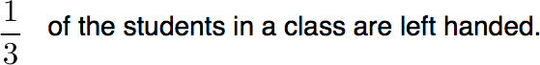  What fraction of the class are right handed? | 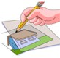
Find the size of angle x | 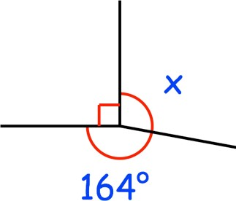
Change 20 kilograms into grams

Heroes Tuition Centre - Homework
© Corbettmaths 2017 www.corbettmaths.com

Name: Silver
Primary 5-a-day

4th October
0.6 + 0.7 + 0.8 + 0.9 | 17 × 4 = 200 −
The numbers in this sequence increase by the same amount each time.  Write the missing number. | 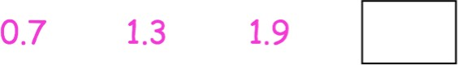
Frank places some oranges on a scale.  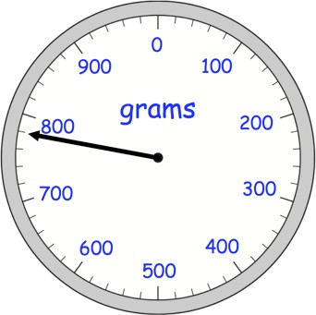 | He takes away one orange.  The mass goes down by 130 grams. Draw the pointer in its new position.

Heroes Tuition Centre - Homework
© Corbettmaths 2017 www.corbettmaths.com

Name: Silver
Primary 5-a-day

5th October
305 + 826 + 185 | 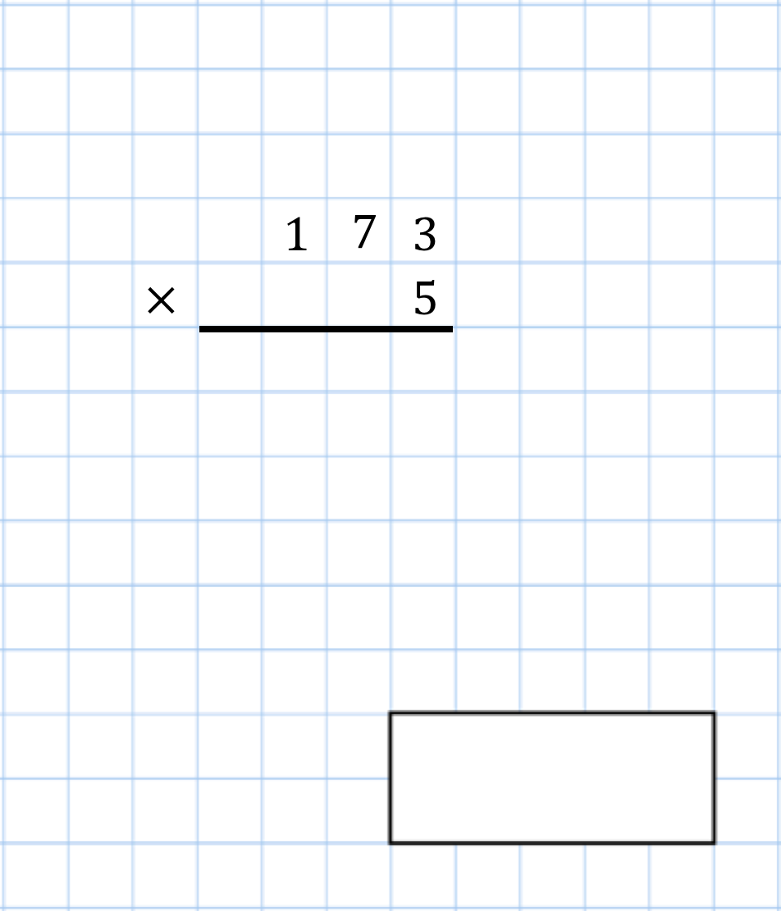
A teacher has 135 sweets.

She shares the sweets equally between 5 children.

How many sweets does each child receive?
Here is part of a number line.  Write the missing numbers in the boxes. | 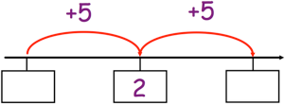
Write the three missing numbers | 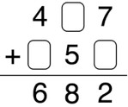

Heroes Tuition Centre - Homework
© Corbettmaths 2017 www.corbettmaths.com
Name: Silver
Primary 5-a-day

6th October
2 of 900  3 | 132 ÷ 11
Hannah has 10p Erin has 64p

How much money should Erin give Hannah so that they have the same amount of money?
A is the point (5, 2) Plot the point A | 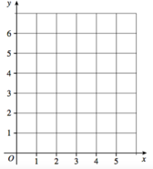
B is the point (0, 3) Plot the point B

Heroes Tuition Centre - Homework
© Corbettmaths 2017 www.corbettmaths.com

Name: Silver
Primary 5-a-day

7th October
9 × 9 × 3 | 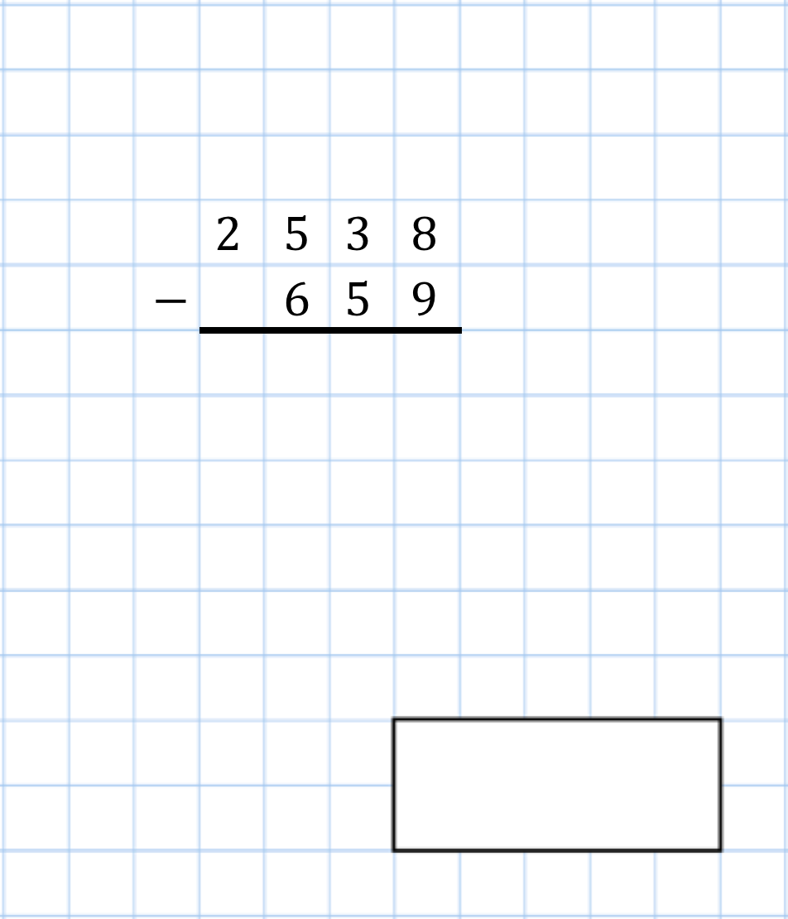
Barry prints books that each have 100 pages.

In total, he prints 9,000 pages. How many books did Barry print?
Megan and her friends visit a cafe Here is the menu  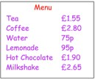  Megan has £10  She buys a tea, a hot chocolate and a water. | How much does Megan have to pay?
 | How much change does she get?

Heroes Tuition Centre - Homework
© Corbettmaths 2017 www.corbettmaths.com
Name: Silver
Primary 5-a-day

8th October
4,000 ÷ 100 | 50,000 − 900
Circle the number that is 10 times greater than eight hundred and forty.

8,040 84 8,004

8,400 840
Six identical boxes are placed in a line. What is the total length of all six boxes? | 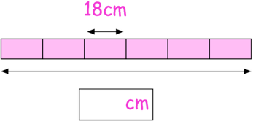
List the factors of 18

Heroes Tuition Centre - Homework
© Corbettmaths 2017 www.corbettmaths.com

Name: Silver
Primary 5-a-day

9th October
9 × 1,000 | 80 × 20
List the first five multiples of 12
Write these numbers in order, starting with the smallest.

5.25 5.2 5.19 5.08 5.1
Work out the perimeter of this square

Heroes Tuition Centre - Homework
© Corbettmaths 2017 www.corbettmaths.com
Name: Silver
Primary 5-a-day

10th October
2 × 3 × 4 × 5 × 6 × 7 | 2,000 ÷ 10
Arrange these temperatures in order, from lowest to highest.

0°C −20°C 6°C 17°C −13°C
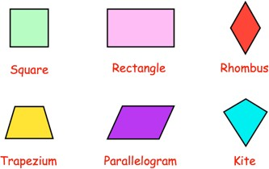 | Which shapes have perpendicular sides?
Using each number card once, make the largest even number

Heroes Tuition Centre - Homework
© Corbettmaths 2017 www.corbettmaths.com

Name: Silver
Primary 5-a-day

11th October
745 − 360 | 9.2 + 5.9
Reflect the shape in the mirror line | 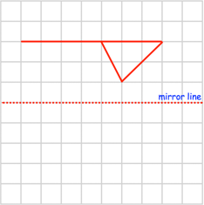
Round 584 to the nearest 10
Here is a number written in Roman numerals

XVIII

Write the number in figures

Heroes Tuition Centre - Homework
© Corbettmaths 2017 www.corbettmaths.com

Name: Silver
Primary 5-a-day

12th October
95 + 95 + 95 | 156 ÷ 6
Change 6 litres into millilitres
There are 8 cupcakes in a box. Neil buys 27 boxes of cupcakes.

How many cupcakes did Neil buy?
Work out the perimeter of this rectangle | 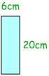

Heroes Tuition Centre - Homework
© Corbettmaths 2017 www.corbettmaths.com

Name: Silver
Primary 5-a-day

13th October
2 − 1  3 3 | 18 × 3 = 60 −
Nicole buys a tie and three pairs of trainers.

She has £50

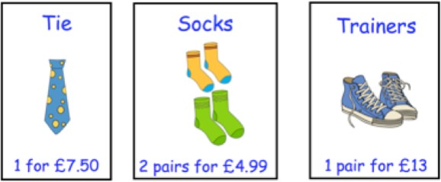

How much change does she get?
Here is a list of numbers.  3 4 5 6 7 9 13 | Circle a factor of 26 and underline a factor of 14.

Heroes Tuition Centre - Homework
© Corbettmaths 2017 www.corbettmaths.com
Name: Silver
Primary 5-a-day

14th October
1,401 + 1,401 + 1,401 | 1 − 6
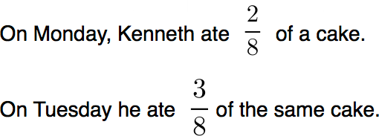

What fraction of the cake is left?
Write down the coordinates of point A | 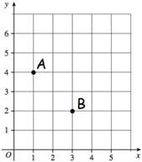
Write down the coordinates of point B

Heroes Tuition Centre - Homework
© Corbettmaths 2017 www.corbettmaths.com

Name: Silver
Primary 5-a-day

15th October
8 × 12 | 2 + 5  15 15
The thermometer below shows the temperature at 6am in a town.  What temperature is shown? | 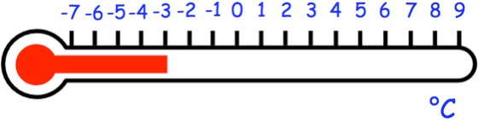
At a party there are 24 tables.

15 tables seat 5 guests
9 tables seat 6 guests

Work out the total number of chairs needed.
Write in the missing numbers | 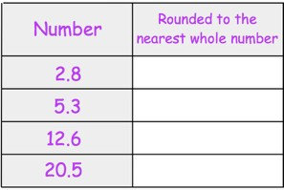

Heroes Tuition Centre - Homework
© Corbettmaths 2017 www.corbettmaths.com
Name: Silver
Primary 5-a-day

16th October
12 × 7 | 4,200 − = 500
Rosie is paid £8 an hour.

In one week Rosie is paid £176 How many hours did Rosie work?
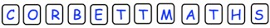  What fraction of the letters are the letter O? | What fraction of the letters are the letter T?
What fraction of the letters are vowels?

Heroes Tuition Centre - Homework
© Corbettmaths 2017 www.corbettmaths.com

Name: Silver
Primary 5-a-day

17th October
121 ÷ 11 | 3.7 + 2.8
Write these numbers in order, starting with the smallest.

0.59 1.24 0.45 1.34 0.88
Match the numbers in Roman numerals to the correct figures | 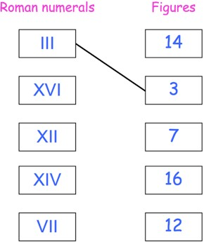

Heroes Tuition Centre - Homework
© Corbettmaths 2017 www.corbettmaths.com

Name: Silver
Primary 5-a-day

18th October
7 × 4 × 3 × 10 | 1 of 42  3
The numbers in this sequence increase by the same amount each time.

Write the missing number.
Aiden has £195
Riley has £26 less than Aiden. Alice has £107 more than Riley.

How much money do they have in total?
What is 235 minutes in hours and minutes?

Heroes Tuition Centre - Homework
© Corbettmaths 2017 www.corbettmaths.com

Name: Silver
Primary 5-a-day

19th October
44 × 8 | 3.3 + 1.8 + 1.1
Arrange these numbers in order, starting with the largest

24,123 24,200 24,032 24,103
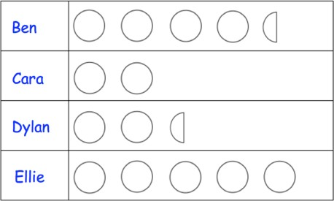  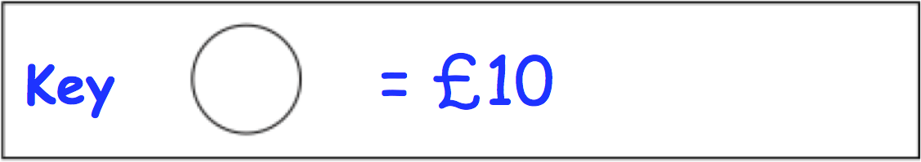 | How much money does Ben have?
Super Bowl LIV will take place in 2020.

Write LIV in figures

Heroes Tuition Centre - Homework
© Corbettmaths 2017 www.corbettmaths.com
Name: Silver
Primary 5-a-day

20th October
15 − 6.4 | 229 × 4
At a football match between Doncaster and Hartlepool, there were 6,723 fans.

Round 6,723 to the nearest thousand.
Tick the two right angles | 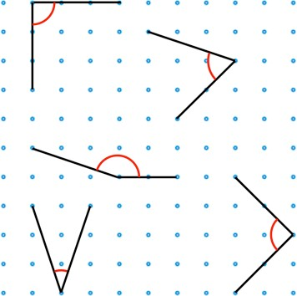
Circle the obtuse angle

Heroes Tuition Centre - Homework
© Corbettmaths 2017 www.corbettmaths.com
Name: Silver
Primary 5-a-day

21st October
9 × 9 × 10 × 10 | 258 ÷ 6
Here is an addition pyramid.  To find the number in a block, add the numbers in the two blocks below it.  Find the missing numbers | 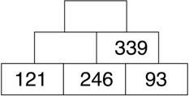
List the factors of 50

Heroes Tuition Centre - Homework
© Corbettmaths 2017 www.corbettmaths.com

Name: Silver
Primary 5-a-day

22nd October
2 of 18  3 | 485 + 193 + 222
It takes an author 105 days to write a book.

How many weeks is this?
Part of a shape is shown on the grid. The shape has one line of symmetry. Complete the shape | 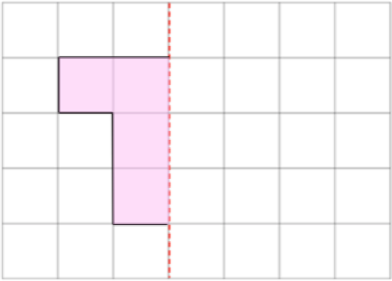
Emma and Tom each buy a toy. Emma’s toy cost £14
Tom pays with a £10 note and gets £5.50 change.

How much more does Emma's toy cost than Tom's toy?

Heroes Tuition Centre - Homework
© Corbettmaths 2017 www.corbettmaths.com

Name: Silver
Primary 5-a-day

23rd October
÷ 100 = 12 | 465 ÷ 5
Change 9 kilometres into metres
These are the temperatures in some towns.  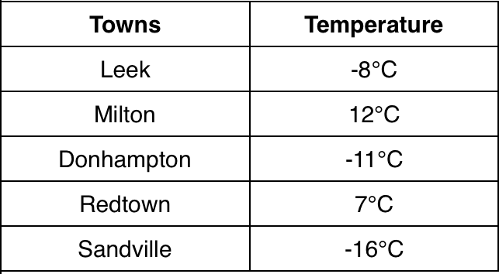 | Which town has the highest temperature?
 | Which town has the lowest temperature?

Heroes Tuition Centre - Homework
© Corbettmaths 2017 www.corbettmaths.com

Name: Silver
Primary 5-a-day

24th October
1 + 1 + 1  5 5 5 | 50 × 100
Find the size of angle x | 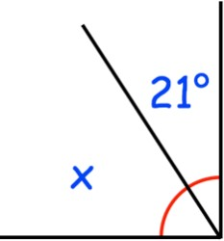
List the first five multiples of 9
500 people went to a charity football match between Yeovil and Carlisle.  Adult tickets are £5. Child tickets are £3.  Out of the 500 people at the match, 100 are children. | How much money was raised for charity?

Heroes Tuition Centre - Homework
© Corbettmaths 2017 www.corbettmaths.com

Name: Silver
Primary 5-a-day

25th October
0.7 + 0.6 | 4 − 7
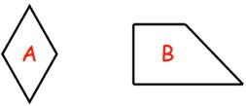 | Name shape A
Name shape B | Draw a scalene triangle
Ryan has these digit cards.  He makes a 1-digit and a 2-digit number. He multiplies them together and the answer is a greater than 600. | What could Ryan’s multiplication be?

Heroes Tuition Centre - Homework
© Corbettmaths 2017 www.corbettmaths.com

Name: Silver
Primary 5-a-day

26th October
7 × 52 | 5 × 30 = 4,000 −
Work out the perimeter of this pentagon | 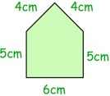
Daisy is reading a book.

She is about to begin reading chapter XXIV

Write XXIV in figures
Write these times in order, starting with the shortest

35 days 3 weeks

1 month 240 hours

Heroes Tuition Centre - Homework
© Corbettmaths 2017 www.corbettmaths.com
Name: Silver
Primary 5-a-day

27th October
80 × 50 | 4 − 1  7 7
Find the size of angle x | 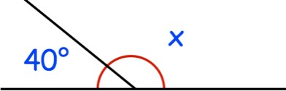
Molly visits a restaurant with her friends. This is a menu.  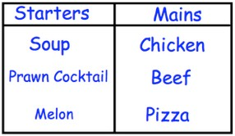  Molly chooses one starter and one main. | List all possible combinations

Heroes Tuition Centre - Homework
© Corbettmaths 2017 www.corbettmaths.com

Name: Silver
Primary 5-a-day

28th October
23 × 7 | 1 of = 9  3
Change 80 millimetres into centimetres
Here is a list of numbers.  4 5 6 7 8  10 12 13 14 | Circle the factors of 24
A rugby team brought 6 coaches of supporters to a cup match.

Each coach held 41 supporters.

How many supporters were brought to the match?

Heroes Tuition Centre - Homework
© Corbettmaths 2017 www.corbettmaths.com
Name: Silver
Primary 5-a-day

29th October
1 of 24  4 | 5,600 + 1,500
Esme buys 3 pencils for 90p.

How much would 4 pencils cost?
Write down the value of the 7 in the answer to 37 × 100
Circle the quadrilateral with exactly three acute angles | 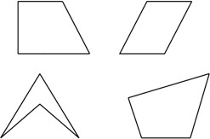

Heroes Tuition Centre - Homework
© Corbettmaths 2017 www.corbettmaths.com

Name: Silver
Primary 5-a-day

30th October
3.4 + 1.9 | 61 × 100
Write the three missing digits to make this subtraction correct. | 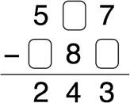
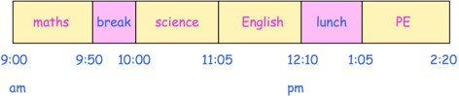
How long does the maths lesson last? | How long does the PE lesson last?

Heroes Tuition Centre - Homework
© Corbettmaths 2017 www.corbettmaths.com
Name: Silver
Primary 5-a-day

31st October
1 + 1 + 1  4 4 4 | 28 × 5
Work out the perimeter of this triangle. | 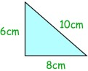
Here is part of a number sequence | Circle all the numbers below that would appear in the sequence  555 620 650 800
What type of triangle is shown? | 